**IM Assignment 5 (Kubernetes)**

*Sanjhana Rangaraj (sr55737)*

*Santhosh Ramkumar (sr55965)*

***Installing Kubernetes***

***Kubernetes Dashboard***

***Create a Minibike Cluster***

***minikube start***

***Deploy an App:***

***Exploring your app:***

***Viewing pods and nodes in the dashboard:***

***Looking for existing pods from Terminal***

***Description of a pod***

***Exposing our app Publicly:***

***Current services in the cluster:***

***Create a new service and expose it to traffic:***

***Using label to query list of pods***

***Scaling your app:***

***Before scaling:***



***Scaling to 4 replicas:***

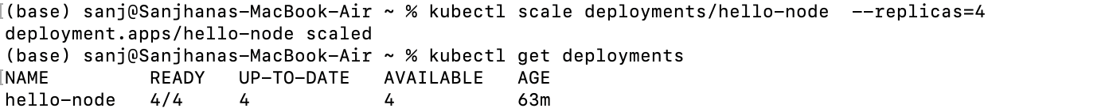

***After Scaling:***

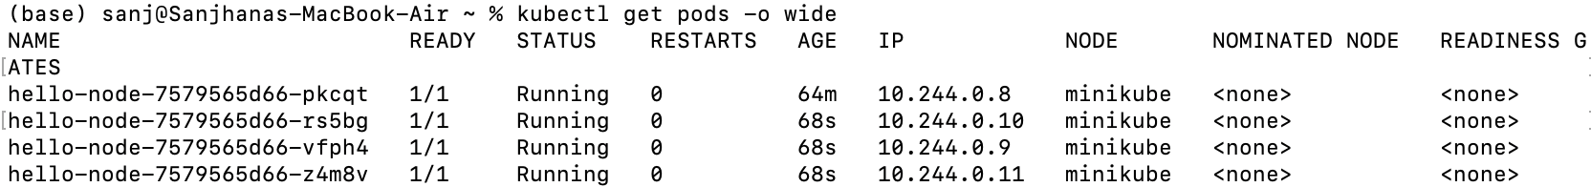

***Scaling down:***

***Update the app:***

***Update and then roll back:***

